Q1.

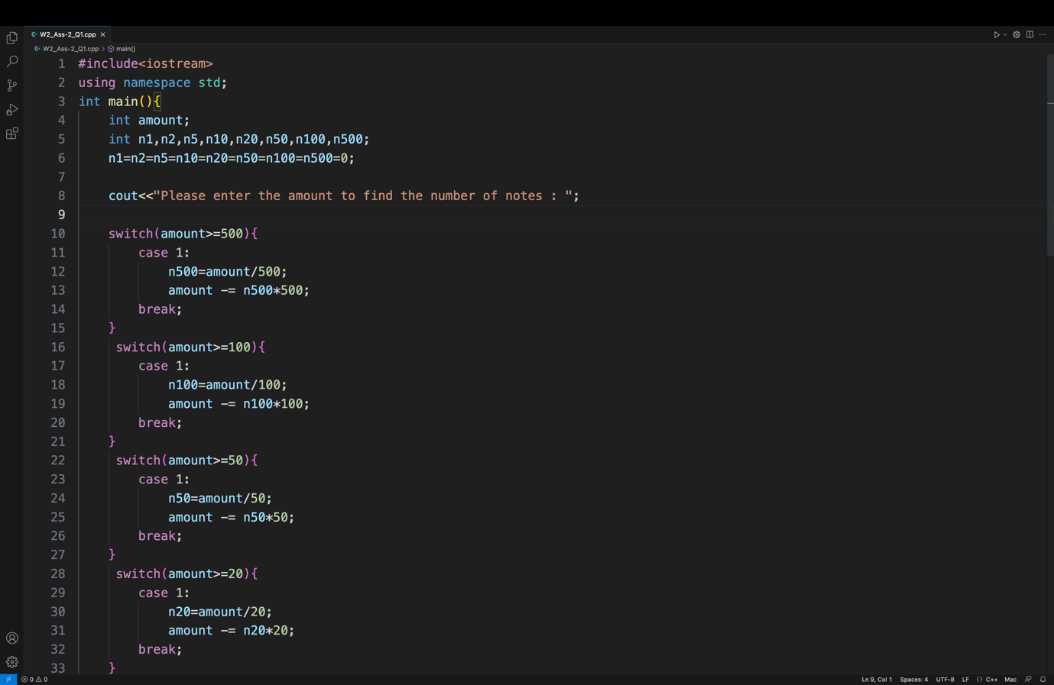

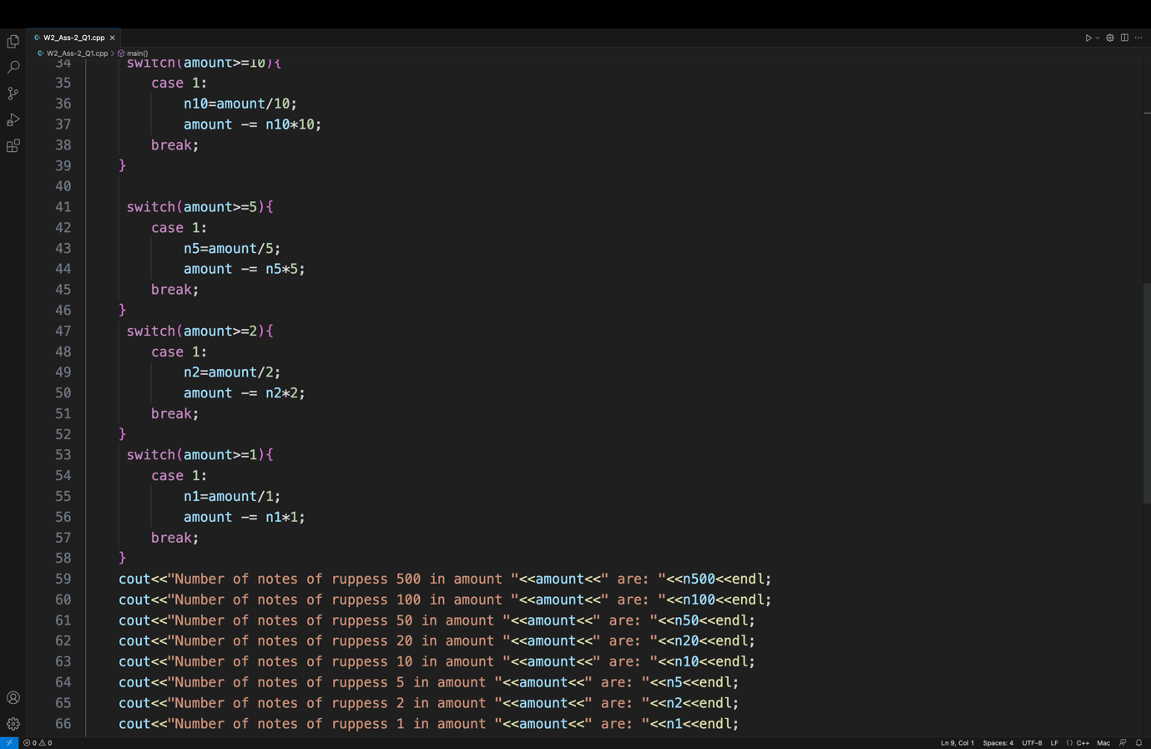

Q2.

a=15,

b=15,

c=0

Q3. x and y are equal

Q4

First character 1

Second character 49

Q5.

Value of t: 0

Q6.

N